HemoSim edit doc - I4
HOW TO USE: edit the wording directly (Track Changes if you like). For layout or a figure (size, position, wrong/missing image) write a short instruction in [brackets] right where it applies. Send it back and I apply the wording to the page and the layout notes to the styling, then regenerate. This is a content+notes doc, so it will not look exactly like the web page.

ISSUES FLAGGED FOR THIS MODULE (8)
These were found while the module was built and are not part of the prose. SOURCE means the defect is in a deck, a Notion page or the source index and has to be fixed there too. DECISION means it needs your call before the page is final. NOTE is for information. Answer them in [brackets] like any other instruction.
[SOURCE: The deck's pulse wave velocity formula is wrong and INDEX.md orphan O9 instructs us to preserve it. "PWV = Zc/blood density" from v2022 slide 139 is dimensionally incoherent and causally backwards. Wix general-8-1 carries the correct Moens-Korteweg form. The page was corrected on 2026-08-16 and both the deck and O9 need fixing.]
[NOTE: A figure caption claiming blood pressure is identical between a coupled and an uncoupled ventricle was corrected. Only end-systolic pressure is shared, and the halved stroke volume means pulse pressure is not.]
[DECISION: Two figures, i4-pv-loop-ees-ea.png and i4-pva-stroke-work.png, are Notion assets renamed as though hand-drawn. The first has "Pagoulatou 2021" baked into the image and that citation is not in the reference list. The Ees 2 to 4 and Ea 1 to 2 mmHg/mL values in the equation legend come from that graphic rather than from a verified paper. Confirm the source so it can be cited, or replace both.]
[DECISION: Karatzas and Lee's 67 percent figure for pulsatile capillary flow traces only to deck slide 137, and the paper has no PubMed abstract. Keep it, or drop it.]
[NOTE: Avolio 2009 carries an erratum, Hypertension 2011;58(4):e30, that the page does not note.]
[NOTE: Lamia 2005 and Kelly 1992 are in the reference list but never cited in the text.]
[DECISION: One sentence copied from Wix says an elevated systolic peak is "a statement about arterial buffering capacity rather than about the heart", which contradicts the page's own three determinants, the first of which is contractility.]
[SOURCE: Wix general-8, general-8-2 and general-8-4 are unedited templates. Wix general-8-5 mis-attributes Weber and Chirinos 2018 as "Chirinos, J., & Weber, T."; the page corrected the order.]

Interface I: LV to the arterial system
Module I3 ended by establishing that a trace can be trusted, and that a number referenced to the room is not the same quantity as a pressure across a wall. This module assumes the trace in front of you is faithful and asks the next question: what does its shape mean, and what has to be true of the ventricle and the arteries to produce it.
The four-interface model in Module N4 put the first interface between the left ventricle and the arterial system, and Module I1 showed that one hydraulic relationship describes all four. What neither could do, because both were building a map rather than a mechanism, is explain why the arterial system has the properties it does. Why blood ejected in a fraction of a second arrives at the capillaries as a nearly steady stream. Why the systolic pressure at the radial artery is not the systolic pressure at the aortic root, while the mean is. And why a ventricle can generate a perfectly respectable blood pressure while wasting most of the energy it spends doing so.
The organising idea is that the arterial system is not a passive set of pipes. It is an elastic reservoir that stores half of every stroke volume and gives it back during diastole, and the ventricle filling it is coupled to it in a mechanically specific sense. Both halves of that coupling are measurable, both change in critical illness, and the pressure on the monitor is a joint product of the two.

The interface, stated exactly
Interface I is the pressure drop from the aortic root to the point at which arterial flow ends, taken across the systemic resistance:
MAP − Pcrit = SVR × COMAP, mean arterial pressure (mmHg); Pcrit, the critical closing pressure of the systemic arterioles, the effective downstream pressure of the arterial circulation (mmHg); SVR, systemic vascular resistance; CO, cardiac output (L/min). Rearranged, MAP = (CO × SVR) + Pcrit.
Two features deserve attention before anything else. The first is the downstream term. The pressure arterial flow drains into is not the right atrial pressure. Arterioles are collapsible vessels with active tone, and flow through them stops at a positive pressure, the critical closing pressure, well above right atrial pressure. That is why the honest form carries a Pcrit term and the version computed by every bedside monitor does not, a point I1 made about the calculated systemic vascular resistance, which uses MAP minus RAP as its numerator and therefore contains a known and unmeasured error. Module I5 derives Pcrit properly. Here it is the boundary of the module: everything upstream of the arteriolar outlet is Interface I, everything downstream is Interface II.
The second feature is that mean arterial pressure, alone among the pressures on an arterial trace, is a property of the circulation rather than of the recording site. Because systemic resistance is concentrated in the small arteries and arterioles, the pressure drop along the conduit arteries is negligible, so a femoral catheter and a radial catheter sample essentially the same mean pressure while reporting very different systolic pressures. That is why MAP appears in the interface equation and systolic pressure does not.
What the equation cannot show is that the interface has a second job beyond setting a mean. The left ventricle delivers its output in about a third of the cardiac cycle and the tissues require flow throughout. Converting one into the other is the work of the arterial reservoir, and the way it does that work determines the shape of everything you read.

The arterial system as a Windkessel
The Windkessel model is named for the air chamber of a hand-operated fire engine. Each pump stroke compresses an enclosed volume of air above the water, and the compressed air pushes water out of the hose continuously between strokes. An intermittent source plus a compliant chamber plus a resistive outlet produces steady output.
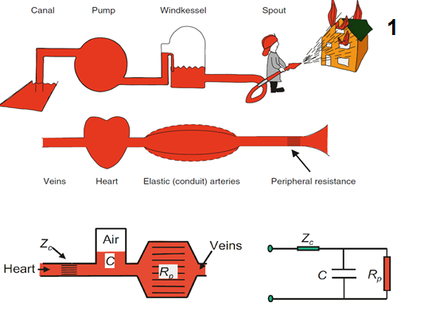
The Windkessel and its circuit analogue. The heart is the pump, the elastic arteries the capacitor, the arterioles the resistor, and the proximal aorta a characteristic impedance in series at the moment of ejection.Source: HemoSim hemodynamics module (v2022), slide 136, after Westerhof N et al, Snapshots of Hemodynamics.
[Layout note: figure shown small here. On the web it is currently capped at 640px wide. Say if you want it smaller/larger, moved, cropped, or replaced.]
Read as a circuit, the model has four elements and each corresponds to something clinically real. The pump is the left ventricle. The first resistor is the characteristic impedance of the proximal aorta, written Zc, the load the ventricle meets in the first instants of ejection before any pressure wave has had time to return, set by aortic diameter, wall stiffness and the inertia of the blood being accelerated. The capacitor is the total compliance of the elastic arteries, dominated by the aorta and the great vessels. The second resistor is total peripheral resistance, the opposition to mean flow imposed by the arterioles, which sets mean pressure for a given cardiac output and governs how fast pressure decays between beats. Those four elements explain the ordinary arterial trace but not the whole of it, because the model treats the arterial tree as if it were distended everywhere at once and has no way to represent a wave travelling and returning.
[Physiologic Insight box: Blood pressure is not a requirement for blood flow, and the pulmonary circulation proves it: the right ventricle moves the entire cardiac output against a transpulmonary gradient of roughly ten millimetres of mercury. So why does the systemic circulation run at eight or nine times that pressure? Because a high upstream pressure lets each vascular bed set its own flow independently, no single dilated organ being able to collapse the pressure the others depend on, which is what makes regional autoregulation possible at all. High systemic pressure is the price of independent regional regulation, and of a load the ventricle can treat as constant, and both benefits are lost in vasoplegia.]
During systole only part of the stroke volume reaches the peripheral circulation. The rest distends the elastic arteries and is held there until diastole. That held fraction is the storage volume, and its ratio to stroke volume is the storage volume fraction.
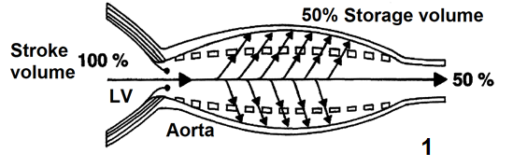
Half of a normal systemic stroke volume never reaches the periphery during systole. It distends the aorta and the great vessels and is delivered during diastole by elastic recoil.Source: HemoSim hemodynamics module (v2022), slide 137, after Belz GG, Cardiovasc Drugs Ther 1995.
[Layout note: figure shown small here. On the web it is currently capped at 400px wide. Say if you want it smaller/larger, moved, cropped, or replaced.]
Belz's review of the elastic properties and Windkessel function of the human aorta puts the systemic storage volume fraction at approximately 50 percent. In the pulmonary circulation, where the vessels are considerably more compliant, Karatzas and Lee's analysis of pulsatile capillary flow puts it nearer 67 percent. The fraction rises with arterial compliance and with peripheral resistance, since both favour retention in the reservoir, and falls when the arteries stiffen.
This distinction changes what systolic pressure means. The peak the arterial system reaches is generated by the volume the arteries had to accommodate, which is the storage volume, not by the stroke volume as such. A young adult with a compliant aorta and a stroke volume of 80 mL stores about 40 mL and generates a modest systolic pressure. An eighty-year-old with the same stroke volume and a stiff aorta stores less, delivers more of it immediately, and generates a considerably higher systolic pressure for exactly the same ejected volume, with nothing about the ventricle changed.
Once the aortic valve closes, inflow stops and the reservoir empties through the peripheral resistance. A compliant chamber draining through a fixed resistance decays exponentially, and one quantity describes the decay.
τ = Rp × Cτ, the arterial time constant (seconds); Rp, total peripheral resistance; C, total arterial compliance. The same product that governs the emptying of a lung unit in mechanical ventilation, applied to a vascular reservoir instead of an alveolar one.
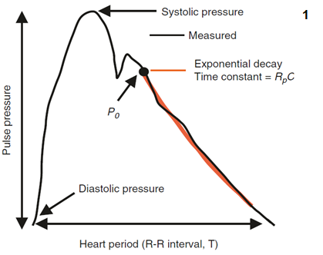
The diastolic limb is a decaying exponential whose time constant is the product of peripheral resistance and total arterial compliance, fitted from just after the dicrotic notch.Source: HemoSim hemodynamics module (v2022), slide 138, after Westerhof N et al, Snapshots of Hemodynamics.
[Layout note: figure shown small here. On the web it is currently capped at 400px wide. Say if you want it smaller/larger, moved, cropped, or replaced.]
The decay is not truly exponential, for two reasons. Arterial compliance is itself pressure dependent, so the reservoir is stiffer at high pressures and no single constant governs the whole range. And wave reflection superimposes returning pressure on the decay. Neither objection removes the usefulness of the concept, which is that the arterial system has a characteristic emptying time, and the relationship between that time and the length of the cardiac cycle determines how much pressure is left when the next beat arrives. Chemla and colleagues made that explicit in 31 adults studied at cardiac catheterisation, finding that the heart period normalised by the diastolic time constant was proportionally related to pulse pressure divided by mean aortic pressure. The quantitative treatment of the time constant belongs to the Expert pathway.

Reading the waveform, feature by feature
Every landmark on an arterial trace is produced by an identifiable physical event and modified by the properties of the reservoir it propagates through. Take them in the order they occur.
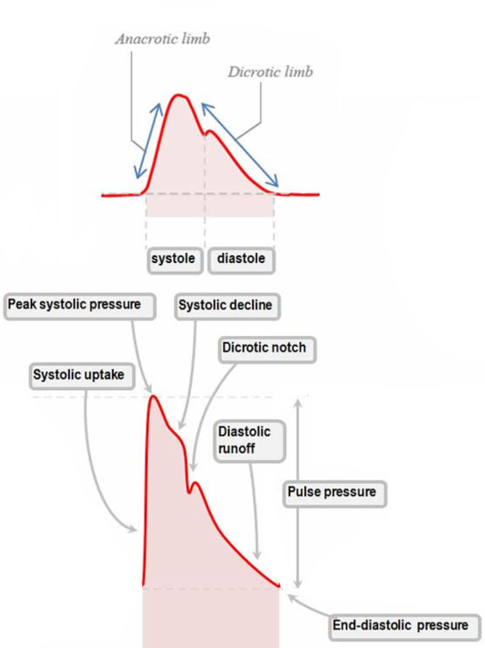
The named components of an arterial pressure waveform. Each is generated by a specific mechanical event and shaped by the compliance and reflective properties of the arterial tree the wave is travelling through.Source: HemoSim hemodynamics module (v2022), slide 114, after Deranged Physiology.
[Layout note: figure shown small here. On the web it is currently capped at 400px wide. Say if you want it smaller/larger, moved, cropped, or replaced.]
The upstroke begins the moment left ventricular pressure exceeds aortic pressure and the valve opens. Its slope is set by three things in series: how fast the ventricle develops pressure and ejects, whether anything obstructs the outflow, and how readily the proximal aorta accepts what arrives. Greater inotropy produces a steeper upstroke. Fixed outflow obstruction blunts it and delays the peak, the mechanism of pulsus parvus et tardus in aortic stenosis. Reduced proximal compliance sharpens the ascent, because a vessel that will not distend converts flow into pressure immediately.
It is tempting to read the upstroke as a contractility monitor, and the temptation should be resisted. The relationship between the rate of pressure rise on a peripheral trace and left ventricular contractility is contested, with some studies finding the radial waveform predicts left ventricular systolic function and others finding it does not. That is unsurprising once you notice the same slope is jointly determined by the ventricle, the valve, and the compliance of everything between the valve and the catheter. A change in slope in one patient over minutes, with vascular properties unchanged, is informative. A single slope against a population norm is not.
The peak has three determinants: contractility, which sets how forcefully the volume is delivered, arterial compliance, which sets how much the proximal vessels expand to receive it, and wave reflection, which sets how much returning pressure is added to the forward wave while ejection is still in progress.
Loss of compliance raises the peak twice over, and the second mechanism is the one clinicians tend to miss. A stiff, atheromatous aorta cannot distend to accept the storage volume, so pressure rises higher for the same ejected volume. Separately, a stiff aorta conducts the pressure wave faster, so waves reflected from downstream branch points return sooner. When they return during systole rather than diastole they summate with the forward wave and raise the peak further. This second contribution is central systolic pressure augmentation, and its magnitude depends on both the size of the reflected wave and the moment it arrives.
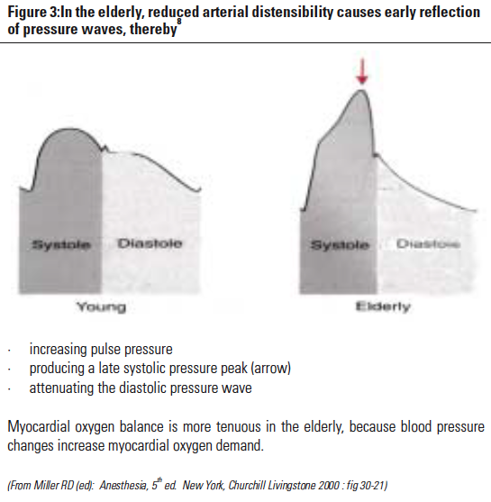
Normal compliance on the left, poor compliance on the right. Three changes travel together: the pulse pressure widens, the peak moves later in systole because the reflected wave arrives during ejection, and diastolic pressure falls away faster because a stiff vessel stores less energy to give back.Source: HemoSim hemodynamics module (v2022), slide 117, after Miller RD (ed), Anesthesia, 5th edition.
[Layout note: figure shown small here. On the web it is currently capped at 520px wide, the default. Say if you want it smaller/larger, moved, cropped, or replaced.]
An elevated peak is therefore a statement about arterial buffering capacity rather than about the heart, and it carries consequences. Both reduced compliance and augmented reflection raise wall stress and myocardial oxygen demand, and where a vessel or a clot is fragile, as after haemorrhage or in aneurysmal disease, high peak pressures can dislodge a haemostatic thrombus or precipitate rupture. Those are the situations in which treating a systolic number rather than a mean is actually justified.
The decline marks the transition from active ejection to passive recoil, and it is steeper when compliance is low because a stiff wall releases its stored energy quickly. The dicrotic notch, or incisura, is generated by aortic valve closure and the brief retrograde flow that rebounds against the closed valve. That is the event, but the notch on the trace is not simply a timestamp for it. Its position and depth are shaped by the interaction of the forward wave with returning reflected waves, so the notch moves when the arterial tree changes even though the valve has not.
The two directions point at opposite pathologies. A notch shifted rightward and low or poorly defined indicates markedly reduced systemic vascular resistance with impaired wave reflection, the signature of vasoplegia and severe distributive shock: forward flow escapes rapidly into a dilated periphery, the backward waves that would normally sharpen the notch are delayed and diminished, and diastolic pressure has already collapsed by the time the valve closes. A notch shifted leftward, toward the systolic peak, indicates poor arterial compliance, where reflected waves return early and the late-systolic contour is compressed. Hernandez, Messina and Kattan make the case that an invasive arterial line is underused when only the mean is read from it, and the notch is a large part of what is thrown away.
Diastolic runoff is the decay of arterial pressure as the reservoir empties with the valve shut, and its slope is governed by the arterial time constant. A steep downslope means a short time constant, in practice low systemic vascular resistance, as with vasodilators or septic shock, or reduced compliance. A shallow downslope means a long time constant, as in cardiogenic shock or intense sympathetic vasoconstriction.
The end-diastolic pressure, which is the diastolic blood pressure on the trace, is simply where that decay has got to when the next beat interrupts it. Diastolic pressure therefore has two determinants and only two: the arterial time constant, and how long diastole lasts, which is set by heart rate. Tachycardia truncates the decay and raises diastolic pressure, bradycardia allows it to run further and lowers it. This is what makes diastolic pressure a window on vascular tone, and why the ratio of heart rate to diastolic pressure carries information neither number carries alone. The clinical use of that ratio, and of the wide and narrow pulse pressure as bedside signals, is taken up in Module I2.
One condition breaks the account. All of it assumes a competent aortic valve. In aortic regurgitation the reservoir empties backwards into the ventricle as well as forwards into the periphery, diastolic pressure falls far below what the time constant predicts, and pulse pressure widens for a reason that has nothing to do with vascular tone.

Systolic, diastolic and pulse pressure do not move together
The three numbers a monitor displays are generated by different mechanisms, and treating them as one quantity called "the blood pressure" discards most of what they carry.
Quantity | Set by | Rises when | Falls when
Systolic pressure | Storage volume, total arterial compliance, and the timing and magnitude of wave reflection | Arteries stiffen, reflections return during systole, stroke volume rises, characteristic impedance rises | Stroke volume falls, outflow is obstructed, contractility falls
Diastolic pressure | The arterial time constant (Rp × C) and the duration of diastole (heart rate) | Resistance rises, compliance rises, heart rate rises | Resistance falls, compliance falls, heart rate falls, aortic regurgitation
Mean pressure | Cardiac output and systemic vascular resistance, read as the area under the trace | Either cardiac output or systemic vascular resistance rises | Either falls, and the fall is not attributable without measuring one of them
Pulse pressure | The difference, so anything that moves systolic or diastolic moves it | Stiff arteries, hyperdynamic circulation, distal recording site, an underdamped line | Low stroke volume, proximal recording site, an overdamped line
Read the mean pressure row against the other three and the central problem of arterial monitoring appears. Mean arterial pressure is the term in the interface equation and the one variable stable across recording sites, which makes it the right number to titrate to. It is also the number carrying the least information about mechanism, because a given MAP is consistent with any combination of cardiac output and resistance whose product is the same. The systolic and diastolic pressures carry the mechanism, and they are the two most corrupted by the recording system and by the site of measurement. The practical consequence is that MAP is what you treat while the contour is what you reason from.
Note also that two entries in the pulse pressure row are artefacts of the recording system rather than physiology. I3 gives the fast flush test that separates them in seconds, and doing it before interpreting a pulse pressure is what separates a reading from a guess.
[Offshoot / At-the-Bedside link: When a blood pressure changes, ask which of the three numbers moved before asking what to do. A fall in systolic with a preserved diastolic and a narrowing pulse pressure points at stroke volume, so the question is filling or contractility. A fall in diastolic with a preserved systolic and a widening pulse pressure points at the time constant, and since compliance rarely changes in minutes, the question is tone. A fall in all three with an unchanged contour is either a genuine fall in mean pressure or a reference error at the transducer, and levelling takes ten seconds to check. Then look at the notch: one that has migrated down and to the right over the last hour is telling you the patient is becoming vasoplegic before the mean pressure has finished falling, which is exactly the window in which the observation is worth something.]

Pulse pressure amplification, and why a radial trace is not an aortic trace
The waveform changes systematically as it travels away from the heart. Moving distally, the upstroke becomes steeper, the systolic peak becomes higher, the dicrotic notch appears later in the cycle, and the diastolic runoff falls lower. Systolic pressure rises and diastolic pressure falls, so pulse pressure widens, while mean pressure stays nearly constant. This is pulse pressure amplification.
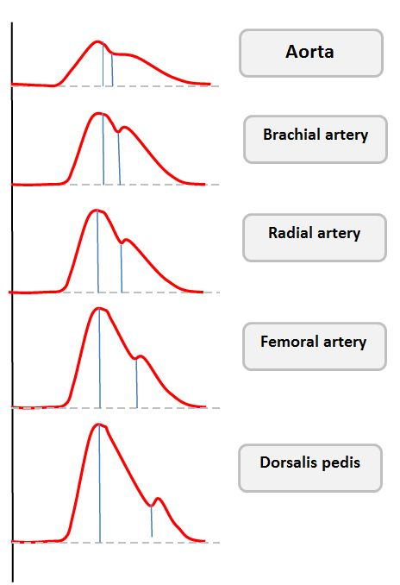
The same beat at five sites. The peak grows and the trough deepens distally, so the pulse pressure at the dorsalis pedis is far wider than at the aortic root while the mean is nearly unchanged.Source: HemoSim hemodynamics module (v2022), slide 123, after Deranged Physiology.
[Layout note: figure shown small here. On the web it is currently capped at 400px wide. Say if you want it smaller/larger, moved, cropped, or replaced.]
The mechanism is wave reflection. Peripheral arteries are smaller, less compliant and closer to the arteriolar reflection sites, so the forward and backward waves synchronise earlier in the cycle and summate more completely there. Pulse wave velocity rises as the vessel stiffens. The Moens-Korteweg relation makes the dependence explicit: wave speed goes as the square root of the elastic modulus and wall thickness, divided by the radius and by blood density, so a stiffer or thicker wall speeds the wave and a wider vessel slows it. Characteristic impedance is derived from that wave speed rather than the cause of it. The full treatment of pulse wave velocity, wave separation into forward and backward components, and the augmentation index belongs to the Expert pathway.
The magnitude is larger than most clinicians assume. Pauca and colleagues cannulated both the radial artery and the ascending aorta in 51 patients undergoing coronary artery bypass grafting. Radial systolic pressure exceeded aortic systolic by 12 plus or minus 1 mmHg, while radial mean differed from aortic by minus 0.8 plus or minus 0.3 mmHg and radial diastolic by minus 1.0 plus or minus 0.3 mmHg. The averages understate the individual variation: radial systolic was 4 to 35 mmHg higher than aortic in 42 of the 51 patients, and 10 to 35 mmHg higher in 26 of them. The radial trace explained 44 percent of the variance in aortic systolic pressure, 90 percent of aortic diastolic and 98 percent of aortic mean.
Three consequences follow. First, a radial systolic pressure is not an estimate of the pressure the ventricle ejected against. The ventricle sees the central pressure, so when a decision turns on ventricular load, as in titrating a vasodilator for aortic dissection, the peripheral systolic number is systematically misleading and the mean is not. Second, a femoral line and a radial line reporting different systolic pressures are usually both correct. Amplification is smaller at the femoral artery, so a femoral trace with a lower systolic and a narrower pulse pressure is expected rather than evidence of damping. Compare the means, which should agree within a few mmHg, and if they do the difference is anatomy rather than fault.
Third, amplification is protective, and losing it is a marker of disease. The normal stiffness gradient between the aorta and the muscular arteries shields the ventricle from the peaks a cuff or a radial line records. With ageing the central arteries stiffen disproportionately, the gradient flattens, amplification falls, and central systolic pressure rises toward the peripheral value. Avolio and colleagues review the evidence that this loss is itself associated with cardiovascular risk, and Chirinos and colleagues place it within the broader picture of large-artery stiffness. The gradient can also invert, so that central pulse pressure exceeds peripheral, a specific feature of sepsis taken up in Module I6.
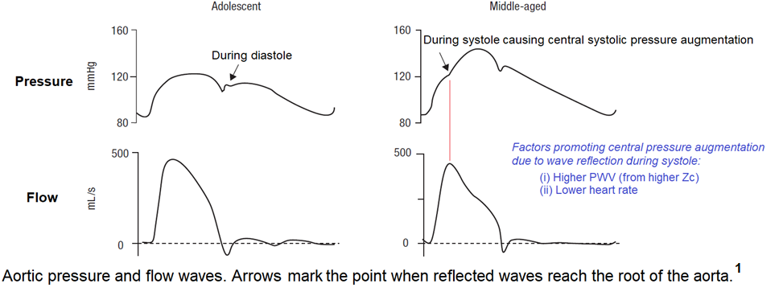
Timing is the whole story. In a compliant aorta the reflected wave arrives after valve closure and augments diastolic pressure, supporting coronary perfusion. In a stiff aorta it arrives during ejection, raising systolic pressure and reducing forward flow at once. A slower heart rate lengthens systole and widens the window in which a reflected wave can arrive while the ventricle is still ejecting.Source: HemoSim hemodynamics module (v2022), slide 140, after McDonald's Blood Flow in Arteries.
[Layout note: figure shown small here. On the web it is currently capped at 640px wide. Say if you want it smaller/larger, moved, cropped, or replaced.]

Ventricular-arterial coupling
Everything so far has treated the ventricle and the arteries as separate objects that happen to be connected. They are better understood as two elastic chambers in series, and the efficiency of the transfer between them determines both how much flow a contraction produces and how much oxygen the myocardium consumes producing it.
Elastance is the pressure change produced by a volume change, the reciprocal notion to compliance. Effective arterial elastance, Ea, asks how much end-systolic arterial pressure is generated for a given ejected volume, and Sunagawa and colleagues defined it in isolated canine ventricles as the slope of the arterial end-systolic pressure to stroke volume relationship.
Ea = Pes ÷ SVEa, effective arterial elastance (mmHg/mL); Pes, left ventricular end-systolic pressure, which in humans averages approximately 90 percent of systolic aortic pressure; SV, stroke volume (mL). Typical adult values are 1 to 2 mmHg/mL.
Ea usefully collapses several features of arterial load into one number, and unhelpfully hides what produced it. Chemla and colleagues resolved that in 20 normotensive and 46 hypertensive subjects spanning mean pressures of 84 to 160 mmHg, fitting Ea to peripheral resistance divided by cycle length and to the reciprocal of compliance. The model was Ea = 1.00 (R ÷ T) + 0.42 (1 ÷ C) − 0.04, with an r2 of 0.97, and the sensitivity of Ea to a change in resistance over cycle length was 2.5 times its sensitivity to an equivalent change in the reciprocal of compliance. Ea is therefore dominated by resistance and heart rate, with compliance a real but secondary contributor. The bedside meaning is direct: raising the heart rate raises arterial elastance, because a shorter cycle leaves less time for the reservoir to empty and the next beat is ejected into a more pressurised system. Tachycardia is an increase in afterload in the sense the ventricle cares about, quite apart from what it does to filling time.
Ea is often called the inverse of total arterial compliance, and it is not. Compliance is estimated as stroke volume divided by pulse pressure, validated by Chemla and colleagues against the area method in 31 adults with a regression slope of 0.99, so its reciprocal is pulse pressure over stroke volume, while Ea is end-systolic pressure over stroke volume. Compliance contributes to Ea, but a high Ea can be driven almost entirely by vasoconstriction and tachycardia with normal pulsatile mechanics.
The ventricle can be characterised the same way, except that its elastance is not fixed. It is a time-varying elastance pump, soft during filling, progressively stiffer through contraction, and maximally stiff at end-systole, and that maximum provides the reference point. Plotting end-systolic pressure against end-systolic volume across a series of differently loaded beats produces the end-systolic pressure-volume relationship, and its slope is end-systolic elastance, Ees.
Ees = ΔP ÷ ΔVEes, end-systolic elastance (mmHg/mL), the slope of the end-systolic pressure-volume relationship. Typical adult values are 2 to 4 mmHg/mL. The relationship extrapolates to a volume-axis intercept V0, the volume at which the ventricle generates no pressure.
Ees is a relatively load-independent index of contractility, which is what makes it worth the trouble. Change the preload and the slope does not move. Change the afterload and the slope does not move. Ejection fraction moves with both. That is the whole reason the pressure-volume framework exists: it separates the intrinsic strength of the ventricle from the conditions it is operating under, which is precisely the separation a bedside ejection fraction cannot make.
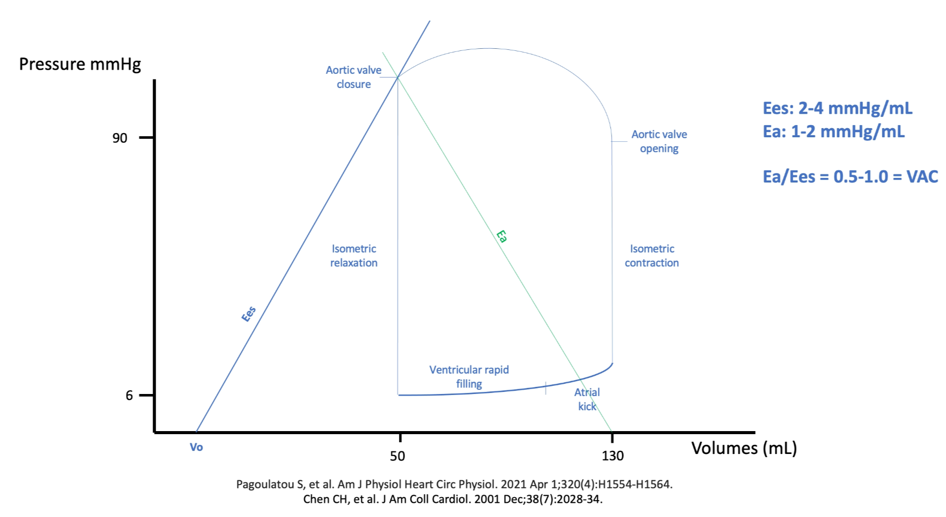
The two elastances meet at the end-systolic point, where the aortic valve closes and forward flow stops. Ees is drawn from the volume-axis intercept and Ea from the end-diastolic volume, and their intersection is the operating point.
[Layout note: figure shown small here. On the web it is currently capped at 640px wide. Say if you want it smaller/larger, moved, cropped, or replaced.]
Historically Ees required multiple differently loaded beats, which confined it to the catheterisation laboratory. Chen and colleagues developed and validated a single-beat estimation from non-invasive pressure and volume measurements, which is what has moved the whole framework within reach of a bedside echocardiogram.
Because Ees and Ea share units, their ratio is dimensionless. Ea divided by Ees is the coupling ratio, normally about 0.5 to 1.0, and that range has a derivation rather than being a convention.
Sunagawa and colleagues supplied the first half in ten isolated canine left ventricles ejecting into a simulated arterial impedance, varying arterial resistance widely at three levels each of end-diastolic volume, contractility, heart rate and arterial compliance. The resistance that maximised stroke work varied widely with contractility and heart rate and only slightly with arterial compliance, but the ratio of the optimal arterial elastance to the ventricular elastance stayed close to unity throughout. Maximum external work is done when the two elastances are equal, which is the general result for transferring potential energy between two elastic chambers.
Burkhoff and Sagawa supplied the second half analytically, and found something more interesting. The afterload producing the greatest efficiency, meaning the largest fraction of energy spent that becomes useful work, is always lower than the afterload producing the greatest stroke work. A normal circulation therefore operates below unity, on the efficiency side of the optimum rather than the work side, which is what the observed 0.5 to 1.0 range represents. Their model also produced the finding with the most direct clinical relevance here: the stroke work and the efficiency of a weak heart are far more sensitive to changes in afterload than those of a strong one. That is the quantitative basis for afterload reduction being a first-line intervention in a failing ventricle and a marginal one in a normal ventricle.
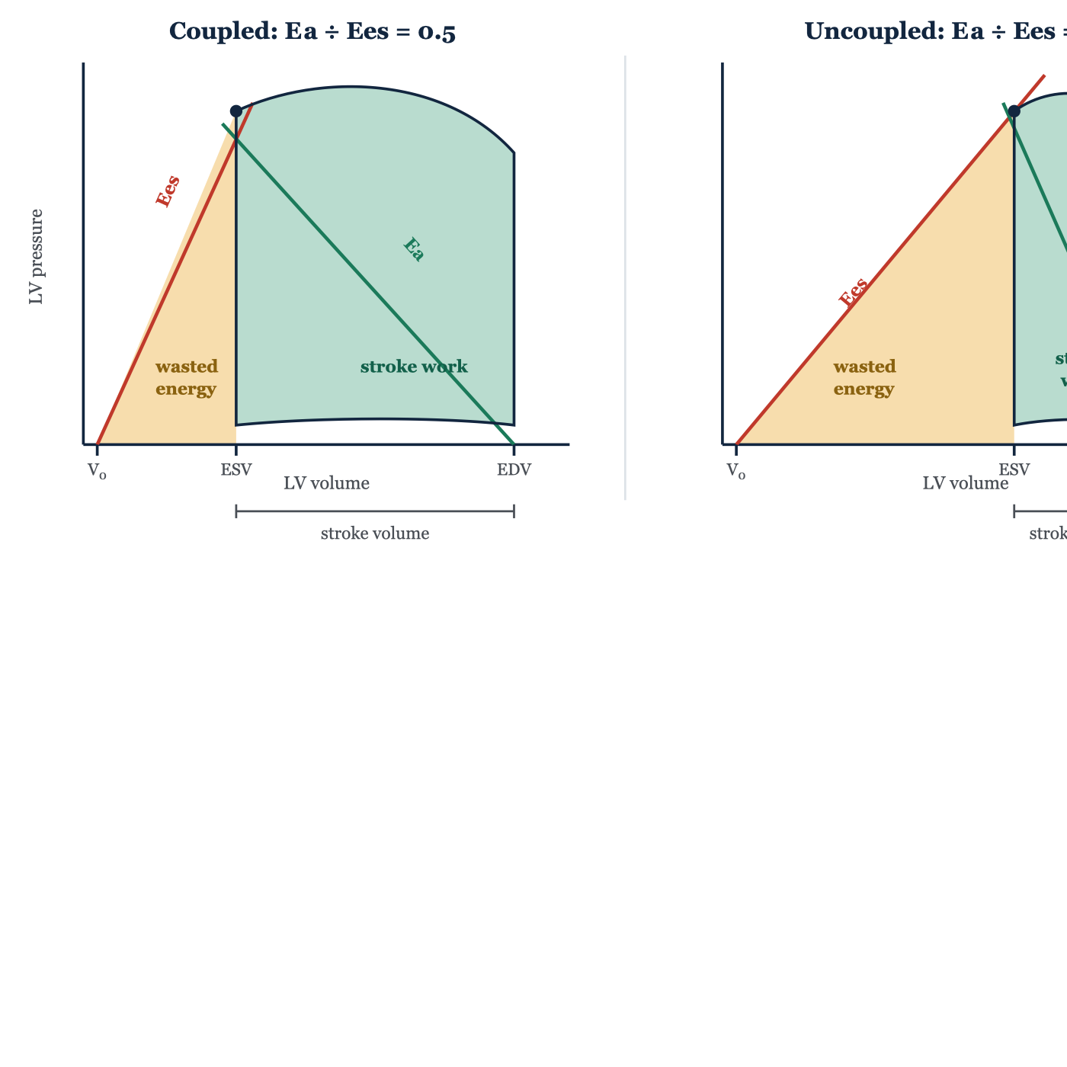
The same end-diastolic volume and the same end-systolic pressure in a coupled and an uncoupled ventricle. On the right the ventricle is half as strong and the load twice as high, so end-systolic volume is much larger, stroke volume is halved, and the fraction of mechanical energy becoming useful work collapses. Note what is and is not held constant. The end-systolic pressure is the same in both panels, but the halved stroke volume on the right means the pulse pressure is not.
[Layout note: figure shown small here. On the web it is currently full column width, about 750px. Say if you want it smaller/larger, moved, cropped, or replaced.]
The energy accounting is what makes the ratio matter rather than merely describe. The total mechanical energy generated in a beat is the pressure-volume area, the sum of the stroke work delivered to the arterial system and the potential energy that remains in the ventricle and is dissipated as heat.
PVA = SW + PE LV efficiency = SW ÷ PVAPVA, pressure-volume area, the total mechanical energy generated per beat; SW, stroke work, the area enclosed by the pressure-volume loop; PE, potential energy, the triangular area bounded by the end-systolic pressure-volume relationship, the end-diastolic relationship and the isovolumic relaxation limb.
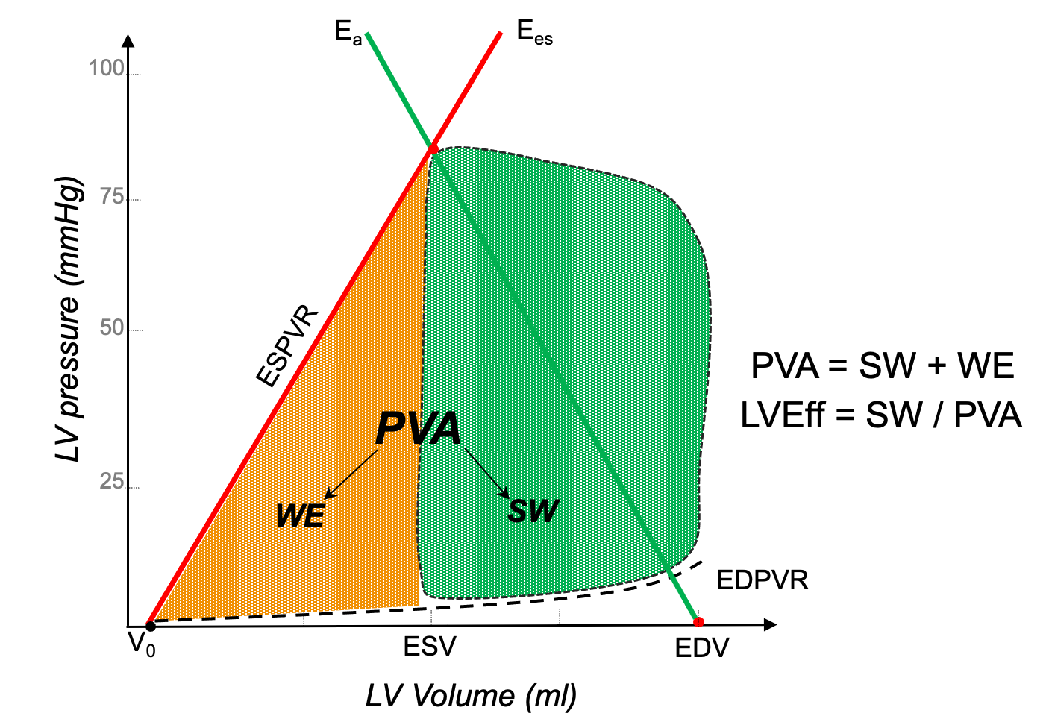
Stroke work is the enclosed loop, the potential energy the ventricle generated but did not convert into flow is the triangle beside it, and their sum is the total mechanical energy of the beat.
[Layout note: figure shown small here. On the web it is currently capped at 640px wide. Say if you want it smaller/larger, moved, cropped, or replaced.]
Suga, Hayashi and Shirahata supplied the link that gives the pressure-volume area its clinical weight. In ten canine hearts, myocardial oxygen consumption per beat was a linear function of the pressure-volume area, VO2 = 1.64 × 10−5 × PVA + 0.015 mL O2 per beat, and the regression was virtually identical for isovolumic and for ejecting contractions. The myocardium pays for total mechanical energy, not for useful work. The positive intercept is the second finding worth carrying: at zero external work, oxygen consumption does not fall to zero, because basal metabolism and excitation-contraction coupling, largely calcium cycling, consume oxygen regardless of what the ventricle achieves.
[Physiologic Insight box: Put the two results together and the vicious cycle of cardiogenic shock stops being a clinical observation and becomes an arithmetic one. Contractility falls, so Ees falls. Compensatory vasoconstriction and tachycardia raise Ea. The ratio rises, the ventricle uncouples, and a smaller fraction of each beat's energy becomes forward flow. But the myocardium is billed for the pressure-volume area, not for the stroke work, so oxygen consumption does not fall in step with the falling output, while the falling stroke volume and diastolic pressure reduce the coronary perfusion that is supplied during diastole. Demand holds up as supply falls, subendocardial ischaemia follows, and ischaemia lowers Ees further. This is why afterload reduction in a failing ventricle is not merely a way of improving output: it moves the operating point back toward the efficiency optimum, lowering the oxygen cost of every subsequent beat.]
The two directions of uncoupling map onto the shock states directly. A low ratio arises when Ees rises, as with inotropic stimulation, or when Ea falls, as in distributive shock: ejection fraction is high, end-systolic volume small, and the ventricle is operating well within its contractile reserve, which is why a septic patient can have a supranormal ejection fraction and still be inadequately perfused. A high ratio arises when Ees falls, as in cardiogenic shock and acute heart failure, or when Ea rises, as in hypertensive emergency. Guarracino, Baldassarri and Pinsky set out how these states present in acutely altered haemodynamics, Caicedo Ruiz and colleagues review coupling specifically in septic shock, and Hungerford and colleagues do the same for advanced heart failure and cardiogenic shock.

Afterload is more than systemic vascular resistance
The word afterload is used for two different quantities and the confusion is not harmless.
Myocardial afterload is the mechanical stress the ventricular wall experiences during contraction, and its closest physical correlate is wall stress, governed by Laplace's law.
σ = (P × r) ÷ 2hσ, wall stress; P, left ventricular pressure; r, chamber radius; h, wall thickness. Wall stress rises through isovolumic contraction, peaks just before the aortic valve opens, and then falls as the chamber empties and the radius shrinks.
Wall stress is a principal determinant of myocardial oxygen consumption. It explains why a dilated ventricle is in mechanical trouble before it is in contractile trouble, since the radius sits in the numerator and the same generated pressure therefore costs a dilated chamber more oxygen, and why hypertrophy is a short-term compensation, since wall thickness sits in the denominator.
Vascular afterload is the external hydraulic load the arterial tree imposes, independent of ventricular geometry. Its complete description is the aortic input impedance, which integrates the steady and pulsatile opposition to flow across all frequencies. The steady part is about 80 percent of the load and the pulsatile part about 20 percent.
Component | What it is | Bedside estimate | Where it dominates
Systemic vascular resistance | The steady opposition set by arteriolar tone, roughly 80 percent of total load | 80 × (MAP − RAP) ÷ CO | Distributive shock, vasoplegia, pure vasoconstrictor therapy
Total arterial compliance | The volume the arteries accept per unit rise in pulsatile pressure | SV ÷ PP | Ageing, chronic hypertension, diabetes, end-stage renal disease
Characteristic impedance Zc | The load met at the very onset of ejection, before any wave returns | No routine bedside estimate | Aortic stiffening and small aortic diameter
Wave reflection | Returning pressure waves that summate with the forward wave, sized by impedance mismatch and timed by pulse wave velocity | Augmentation index, with substantial caveats | Stiff arteries, low heart rate, intense arteriolar vasoconstriction
Reducing all of that to a calculated systemic vascular resistance is defensible as shorthand and indefensible as a model, and three specific failures follow. Two patients with the same calculated resistance can have very different systolic and diastolic pressures because compliance and reflection differ, and treating them as identical produces the wrong therapy in at least one. A low stroke volume caused by a high characteristic impedance looks like a contractility problem and does not respond to inotropes. And an arterial trace with multiple systolic shoulders in a stiff, calcified tree is frequently reported as underdamping when it shows genuine early wave reflection, reproducible beat to beat and following the dicrotic notch rather than preceding it.
Weber and Chirinos make the general case for pulsatile load as a distinct dimension, and Chirinos and colleagues develop it across the natural history of large-artery stiffening. The argument is that mean pressure and resistance describe how high the load is, while compliance, impedance and reflection describe when during systole it is imposed, and the ventricle is far more vulnerable to load arriving late in ejection than early. The full treatment of input impedance and wave separation belongs to the Expert pathway.

Pressure is not perfusion
The phrase is used so freely that it has almost stopped meaning anything. Magder's argument in "The meaning of blood pressure" is worth taking literally, because it is a claim about energy rather than a caution about over-interpretation.
Blood pressure is not flow. It is stored energy, the potential for flow. Each contraction imparts energy that partitions into a kinetic component moving blood forward, an elastic component held in the distended arterial walls, and a small gravitational component. What you measure is the elastic component: the arterial walls are a bank of springs the heart stretches during systole and that recoil during diastole, and the height of the pressure says how much potential energy those springs hold, not whether it is being converted into movement.
Conversion requires a gradient and it requires open vessels, and either can fail with the pressure unchanged. The downstream end of that gradient is not the central venous pressure but the critical closing pressure of the bed in question, so the true driving pressure for a tissue is MAP minus Pcrit. If arteriolar tone, external compression or microvascular obstruction raises Pcrit toward the arterial pressure, flow in that bed stops though the monitor reads a respectable number, and when Pcrit falls with vasodilation, adequate flow can occur at a modest pressure. Module I5 derives Pcrit and takes up autoregulation and the choice of a MAP target, and Module I6 takes up the microcirculatory failure that persists after the macrocirculation has been restored.
Interface I adds a third failure mode. Even with an adequate gradient and open vessels, the energy has to be generated efficiently to be worth generating. A ventricle uncoupled from its load produces the pressure and pays for it twice, once in the oxygen consumed to generate the pressure-volume area and again in the fraction of that area that never becomes flow. Two patients with a mean arterial pressure of 70 can differ in stroke volume by a factor of two and in coupling ratio by a factor of four. Pressure is the same in both. Perfusion is not, and neither is the sustainability of the arrangement.
None of this means pressure should be ignored. Magder's larger argument, developed in his account of meaningful clinical targets in shock, is that pressure is a means rather than an end: necessary, because without a gradient there is no flow, and insufficient, because a gradient does not guarantee that flow reaches tissue. What follows is a preference for interventions that improve several terms at once. Noradrenaline recruits unstressed venous volume, raises arteriolar tone and has a beta-1 inotropic effect, so it tends to raise pressure and flow together. A pure alpha agonist raises pressure by raising Ea alone, which raises the coupling ratio, lowers stroke volume and increases the oxygen cost of each beat. Both raise the number on the monitor. Only one has necessarily improved the transfer of energy into flow.
What Interface I hands downstream is a mean pressure and a critical closing pressure, and the difference between them is the entire budget available to the tissues. Module I5 takes that budget to the arterioles, derives the critical closing pressure named here as a boundary term, and asks what a mean arterial pressure target actually means for an individual patient whose autoregulatory range has shifted. Module I2 takes the same waveform to the bedside and asks what a narrow or a wide pulse pressure, and a normal blood pressure in a shocked patient, should make you do. The deeper arterial physiology, the arterial time constant in full, pulse wave velocity and wave separation, and the characteristic waveforms of aortic stenosis, dynamic outflow tract obstruction and chronic hypertension, is left to the Expert pathway.

References
To DROP a reference, strike it. To ADD one, write [add: author, year, journal, roughly what it is] rather than typing the citation out. Do not correct the text of an entry here: every author list, volume, issue, page range, year and DOI is fetched from PubMed when the page is rebuilt, so an edit made here is discarded and a typo made here is caught. This list is what the page currently carries.
1. Belz GG. Elastic properties and Windkessel function of the human aorta. Cardiovasc Drugs Ther. 1995;9(1):73-83. doi:10.1007/BF00877747.
2. Karatzas NB, Lee Gde J. Propagation of blood flow pulse in the normal human pulmonary arterial system. Analysis of the pulsatile capillary flow. Circ Res. 1969;25(1):11-21. doi:10.1161/01.res.25.1.11.
3. Chemla D, Hebert JL, Coirault C, Zamani K, Suard I, Colin P, Lecarpentier Y. Total arterial compliance estimated by stroke volume-to-aortic pulse pressure ratio in humans. Am J Physiol. 1998;274(2):H500-H505. doi:10.1152/ajpheart.1998.274.2.H500.
4. Chemla D, Antony I, Lecarpentier Y, Nitenberg A. Contribution of systemic vascular resistance and total arterial compliance to effective arterial elastance in humans. Am J Physiol Heart Circ Physiol. 2003;285(2):H614-H620. doi:10.1152/ajpheart.00823.2002.
5. Sunagawa K, Maughan WL, Burkhoff D, Sagawa K. Left ventricular interaction with arterial load studied in isolated canine ventricle. Am J Physiol. 1983;245(5 Pt 1):H773-H780. doi:10.1152/ajpheart.1983.245.5.H773.
6. Sunagawa K, Maughan WL, Sagawa K. Optimal arterial resistance for the maximal stroke work studied in isolated canine left ventricle. Circ Res. 1985;56(4):586-595. doi:10.1161/01.res.56.4.586.
7. Burkhoff D, Sagawa K. Ventricular efficiency predicted by an analytical model. Am J Physiol. 1986;250(6 Pt 2):R1021-R1027. doi:10.1152/ajpregu.1986.250.6.R1021.
8. Suga H, Hayashi T, Shirahata M. Ventricular systolic pressure-volume area as predictor of cardiac oxygen consumption. Am J Physiol. 1981;240(1):H39-H44. doi:10.1152/ajpheart.1981.240.1.H39.
9. Kelly RP, Ting CT, Yang TM, Liu CP, Maughan WL, Chang MS, Kass DA. Effective arterial elastance as index of arterial vascular load in humans. Circulation. 1992;86(2):513-521. doi:10.1161/01.cir.86.2.513.
10. Chen CH, Fetics B, Nevo E, Rochitte CE, Chiou KR, Ding PA, Kawaguchi M, Kass DA. Noninvasive single-beat determination of left ventricular end-systolic elastance in humans. J Am Coll Cardiol. 2001;38(7):2028-2034. doi:10.1016/s0735-1097(01)01651-5.
11. Pauca AL, Wallenhaupt SL, Kon ND, Tucker WY. Does radial artery pressure accurately reflect aortic pressure? Chest. 1992;102(4):1193-1198. doi:10.1378/chest.102.4.1193.
12. Avolio AP, Van Bortel LM, Boutouyrie P, Cockcroft JR, McEniery CM, Protogerou AD, Roman MJ, Safar ME, Segers P, Smulyan H. Role of pulse pressure amplification in arterial hypertension: experts' opinion and review of the data. Hypertension. 2009;54(2):375-383. doi:10.1161/HYPERTENSIONAHA.109.134379.
13. Lamia B, Chemla D, Richard C, Teboul JL. Clinical review: interpretation of arterial pressure wave in shock states. Crit Care. 2005;9(6):601-606. doi:10.1186/cc3891. Free full text.
14. Guarracino F, Baldassarri R, Pinsky MR. Ventriculo-arterial decoupling in acutely altered hemodynamic states. Crit Care. 2013;17(2):213. doi:10.1186/cc12522. Free full text.
15. Weber T, Chirinos JA. Pulsatile arterial haemodynamics in heart failure. Eur Heart J. 2018;39(43):3847-3854. doi:10.1093/eurheartj/ehy346. Free full text.
16. Chirinos JA, Segers P, Hughes T, Townsend R. Large-artery stiffness in health and disease: JACC state-of-the-art review. J Am Coll Cardiol. 2019;74(9):1237-1263. doi:10.1016/j.jacc.2019.07.012. Free full text.
17. Hernandez G, Messina A, Kattan E. Invasive arterial pressure monitoring: much more than mean arterial pressure! Intensive Care Med. 2022;48(10):1495-1497. doi:10.1007/s00134-022-06798-8.
18. Caicedo Ruiz JD, Aldana JL, Kattan E, Orozco N, Garcia Gallardo G, Sanchez JIA, Diaztagle Fernandez JJ, Mallat J, Ospina-Tascon GA. Left ventricular-arterial coupling in septic shock: a physiological review. J Crit Care. 2026;93:155486. doi:10.1016/j.jcrc.2026.155486.
19. Hungerford SL, Everett KD, Gulati G, Sunagawa K, Burkhoff D, Kapur NK. Systemic circulation in advanced heart failure and cardiogenic shock: state-of-the-art review. Circ Heart Fail. 2025;18(2):e012016. doi:10.1161/CIRCHEARTFAILURE.124.012016.
20. Magder S. The meaning of blood pressure. Crit Care. 2018;22(1):257. doi:10.1186/s13054-018-2171-1. Free full text.
21. Magder SA. The highs and lows of blood pressure: toward meaningful clinical targets in patients with shock. Crit Care Med. 2014;42(5):1241-1251. doi:10.1097/CCM.0000000000000324.

